**UNIT 9 PRACTICE TEST** Name __________________________

**Multiple Choice Questions**

1. Ionic bonds are normally formed when
2. electrons are shared between a metal and a nonmetal
3. electrons are shared between two nonmetals
4. electrons are transferred from a metal to a nonmetal
5. electrons are transferred from a nonmetal to a metal
6. Covalent bonds are normally formed when
7. electrons are shared between a metal and a nonmetal
8. electrons are shared between two nonmetals
9. electrons are transferred from a metal to a nonmetal
10. electrons are transferred from a nonmetal to a metal
11. Which of these compounds is classified as IONIC?
12. CO2 C. SF2
13. ZnCl2 D. SeBr2
14. Which of these compounds is classified as COVALENT?
15. A. PF3 C. GaCl3
16. C. NiBr3 D. CrO3
17. Which of these compounds requires a Roman numeral in its name?
18. SF6 C. ZnO
19. AlBr3 D. PdCl2
20. The correct formula for strontium phosphide is
21. Sr2P3 C. Sr3P2
22. SrPO4 D. Sr3(PO4)2
23. The correct formula for aluminum sulfide is
24. Al2S3 C. Al3S2
25. AlSO4 D. Al2(SO4)3
26. The correct formula for calcium hydroxide is
27. CaO C. CaH2
28. CaOH2 D. Ca(OH)2
29. The correct name for Na3N is
    1. sodium nitride
    2. trisodium mononitride
    3. sodium(III) nitride
    4. sodium nitrate
30. The correct name for CaCl2 is
    1. calcium(II) chloride
    2. calcium chloride
    3. calcium dichloride
    4. calcium chlorate
31. The correct formula for sodium carbonate is
32. Na4C C. NaCO3
33. Na2CO3 D. Na3CO3
34. The correct name for Mg(NO3)2 is
    1. magnesium nitride
    2. magnesium nitrate
    3. magnesium dinitrate
    4. magnesium(II) nitrate
35. The correct formula for dinitrogen trioxide is
36. N2O C. N2O3
37. N2O4 D. N3O2
38. The correct name for SF4 is
    1. sulfur(IV) fluoride
    2. sulfur fluoride(IV)
    3. sulfur trifluoride
    4. sulfur tetrafluoride
39. Which of the following choices has classified both bonds correctly?

|  |  |  |
| --- | --- | --- |
|  | Covalent Bond | Ionic Bond |
| (A) | C–Cl | H–N |
| (B) | Na–I | Sr–Br |
| (C) | Sc–F | S–P |
| (D) | H–O | Ca–N |

1. As a bond between a hydrogen atom and a sulfur atom is formed, electrons are
   1. Shared to form an ionic bond
   2. Shared to form a covalent bond
   3. Transferred to form an ionic bond
   4. Transferred to form a covalent bond
2. Which of the following Lewis dot diagrams is correct?

(A) (C)

C

N

(B) (D)

O

B

1. The molecular shape of BF3 is
2. bent C. tetrahedral
3. pyramidal D. trigonal planar
4. The molecular shape of silicon dioxide is
5. linear C. bent
6. pyramidal D. trigonal planar
7. Given the Lewis structure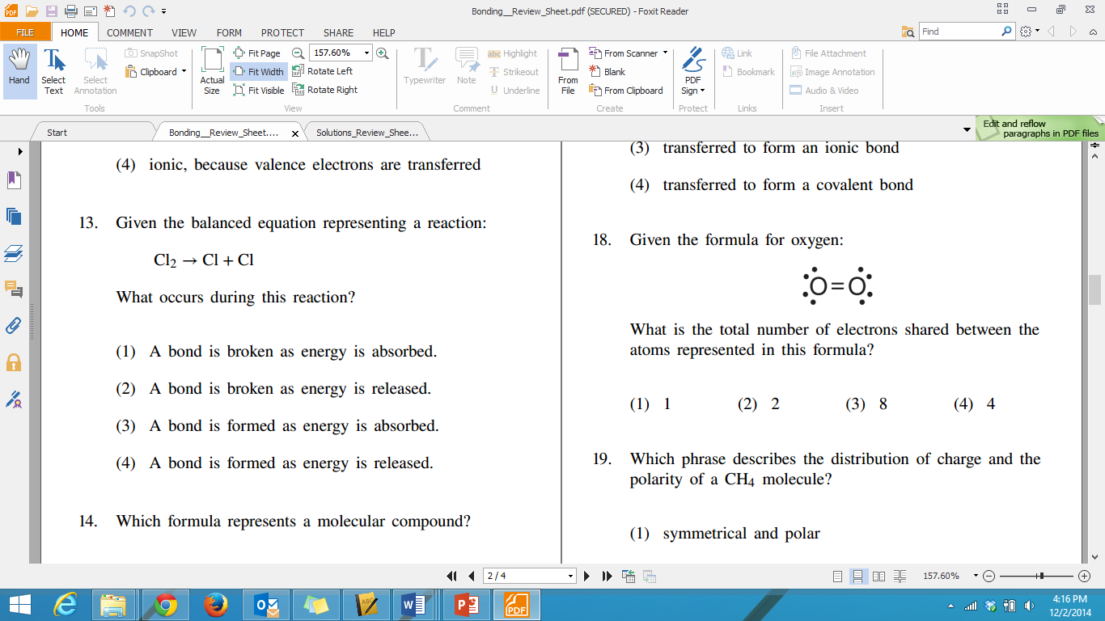, what is the total number of electrons shared between the two oxygen atoms?
   1. 1 C. 3
   2. 2 D. 4
8. 

Which of the atoms in the Lewis structure above has violated the octet rule?

1. sulfur C. chlorine
2. carbon D. oxygen
3. Which of the Lewis structures below best represents the molecule C2H3Cl ?
4.  C.



1. D.
2. Hexane (C6H14) and water do not form a solution. Which statement explains this phenomenon?
3. Hexane is polar and water is nonpolar.
4. Hexane is ionic and water is polar.
5. Hexane is nonpolar and water is polar.
6. Hexane is nonpolar and water is ionic.
7. Which of the Lewis structures below best represents the molecule CHF3 ?
8.  B.

C. D.

1. Electronegativity is defined as the tendency of an atom to
2. donate electrons to other atoms in a chemical bond
3. share electrons equally with other atoms
4. lose its valence electrons to become an ion
5. attract electrons towards itself in a chemical bond
6. Based on its location on the periodic table, which of the following elements should have the largest value for electronegativity?
7. lithium C. potassium
8. oxygen D. Selenium
9. Which formula represents a nonpolar molecule containing polar covalent bonds?
10. H2O
11. CCl4
12. NH3
13. H2

**SHORT ANSWERS**

1. Decide if the description represents IONIC bonding or COVALENT bonding

_______________________It is a non conductor of electricity, whether it exists as a solid,

melted, or dissolved in water.

_______________________It is a nonelectrolyte in the solid form, but it can become a good

conductor when melted or dissolved in water.

_______________________The building blocks of this type of compound are called molecules.

_______________________The electrons are transferred from one element to another to form this type of bond.

________________________The electrons are shared in between elements in this type of bond.

1. Rank from ionic, covalent and metallic from strongest to weakest strength between molecules

**NAMING COMPOUNDS & WRITING CHEMICAL FORMULAS PRACTICE**

1. **Simple Binary Ionic Compounds:**
2. MgCl2 1. Lithium oxide
3. NaI 2. Barium fluoride
4. Na2S 3. Cesium sulfide
5. Cs2Se 4. Beryllium oxide
6. Al2S3  5. Strontium iodide
7. **Binary Ionic Compounds with Multi-Valent Metals:**
8. FeCl3 1. Chromium (IV) sulfide
9. SnS2 2. Cobalt (II) bromide
10. Ti2O3 3. Nickel (III) phosphide
11. PbF2 4. Gold (I) nitride
12. PtSe2 5. Iron (II) arsenide
13. **Ionic Compounds with Polyatomic Ions:**
14. NaCH3COO 1. Silver nitrate
15. ZnCO3 2. Ammonium hydroxide
16. Al(NO3)3 3. Magnesium Phosphate
17. KNO3 4. Lead (IV) nitrate
18. Zn3(PO4)2 5. Iron (III) carbonate
19. **Covalent Compounds:**
20. SF6 1. Nitrogen monoxide
21. P2O5 2. Carbon dioxide
22. SiO4 3. Bromine trioxide
23. NO2 4. Xenon hexafluoride
24. H2O 5. Difluorine disulfide

**LEWIS STRUCTURES**

1. What is meant by the HONC Rule and Octet Rule for bonding? What are the exceptions?
2. Draw two Lewis structures for HCl, N2, and NH3 and place them in the proper boxes based on the type of intermolecular forces found between the molecules. Then, rank them in terms of their relative strengths using the number 1, 2, and 3, where 1 is used to indicate the strongest of these forces.

|  |  |  |  |
| --- | --- | --- | --- |
| **IMF** | **London Dispersion** | **Hydrogen Bonding** | **Dipole-Dipole** |
| **Lewis Structures** |  |  |  |
| **Ranking** |  |  |  |

1. Naphthalene, a nonpolar substance that sublimes at room temperature, can be used to protect wool clothing from being eaten by moths. Explain why naphthalene is not expected to dissolve in water.
2. Complete the following table

|  |  |  |  |  |
| --- | --- | --- | --- | --- |
|  | **Essential Information:** | **Structure:** | **Essential Questions:** | **Additional Information:** |
| **NH3** | Total valence electrons: |  | VSEPR Formula  Shape:  Hybridization | Polar or Nonpolar Molecule: |
| Electrons in Bonds: | Major intermolecular force: |
| Electrons in Lone Pairs: |
| **CO2** | Total valence electrons: |  | VSEPR Formula  Shape:  Hybridization | Polar or Nonpolar Molecule: |
| Electrons in Bonds: | Major intermolecular force: |
| Electrons in Lone Pairs: |
| **C2F2** | Total valence electrons: |  | VSEPR Formula  Shape:  Hybridization | Polar or Nonpolar Molecule: |
| Electrons in Bonds: | Major intermolecular force: |
| Electrons in Lone Pairs: |