Unit 7 Review Name_________________________

Biology Date ________________ Block ____

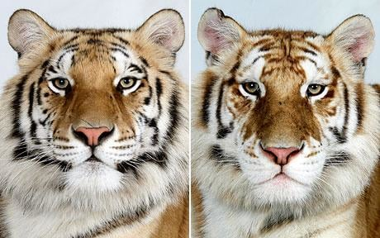

* 1. What does **variation** mean? Name one variation between the two tigers.

* 1. What is meant by evolution by natural selection?
  2. What is an **adaptation**? Describe an adaptation that a bird might have to help it reach a food source.
  3. Explain how camouflage can be an adaptation.
  4. What does it mean for an animal to be “fit” or have a high **fitness**? Before the industrial revolution, why were the light colored pepper moths considered more “fit?”
  5. What is a **homologous structure**? Give an example. How does it provide evidence for evolution?
  6. What is an **analogous structure**? Give an example. Does it tell us anything about how species are related?
  7. What is a **vestigial structure**? Give an example. How does it provide evidence for evolution?
  8. How does **embryology** provide evidence for evolution?

Matching: Match the following terms with the correct statement. Each statement may be used only once.

# One organism benefits without harming the other

1. An organism that eats only plants
2. A relationship in which both organisms benefit
3. Organisms that cannot make their own food
4. The place where an organism lives
5. A relationship in which one organism benefits but harms the other
6. Organisms that can make their own food
7. The population size that can be supported by the amount of available resources (food, space, water).
8. An organism that hunts
9. Organisms that eats only meat
10. Organism that breaks down dead material
11. A biotic or abiotic factor that restricts/regulates the size of a population
12. Organism that eats both plant and animals
13. Organisms that are hunted
14. Heterotroph
15. Prey
16. Carnivore
17. Autotroph
18. Habitat
19. Parasitism
20. Commensalism
21. Carrying capacity
22. Herbivore
23. Mutualism
24. Decomposer
25. Omnivore
26. Predator
27. Limiting Factor

**Food Chains/Webs**

* + - 1. Pick one food chain in the food web above. Label the primary producer, primary consumer, secondary consumer, etc.

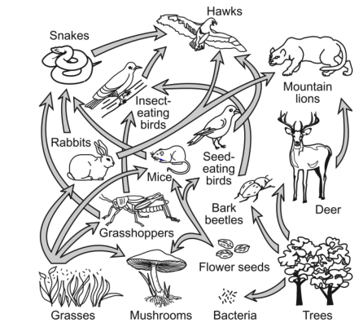

* + - 1. List 2 (or more) species that have a competitive relationship
      2. What would be the immediate consequences on the population of other species if the population of insect eating birds suddenly decreased?

1. Charles Darwin proposed his theory of evolution based on observations of nature. Which observation that contributed to his theory is illustrated by this population of beetles?

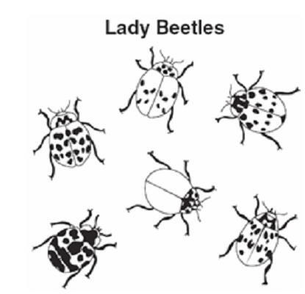

* 1. Environmental resources are limited.
  2. Populations remain stable over time.
  3. Individuals within a population may vary widely.
  4. Species produce more offspring than can survive.

1. Two plant species found in a dry region of the western United States exhibit vastly different abilities to survive. Species A has very slow stem growth and few leaves but is very abundant. Species B has rapid stem growth and many leaves but is very rare. Which hypothesis is most likely supported by this information?
   1. Leaf shape may give species B an advantage over species A.
   2. Flower size and color may give species B an advantage over species A.
   3. Reduced root growth may give species A an advantage over species B.
   4. Reduced stem growth may give species A an advantage over species B
2. The nonpoisonous eastern scarlet snake has colored bands that closely resemble the poisonous coral snake. This selective adaptation provides the eastern scarlet snake with
   1. increased breeding opportunities
   2. a method of avoiding predation
   3. the ability to attract prey
   4. increased feeding opportunities
3. Dutch Elm Disease is a destructive fungal infection that kills elm trees. Some elms are more resistant to the disease than other elms. Which best explains this difference?
   1. Resistant trees form a symbiotic relationship with the fungus.
   2. Resistant trees gain resistant properties from the soil.
   3. Resistant trees have beneficial variations of some genes.
   4. Resistant trees produce frequent mutations.
4. Which of the following statements describes the process of natural selection?
   1. Farmers select animals with desirable variations for breeding.
   2. Populations sharing the same gene pool interbreed and create new species.
   3. Individuals survive that have inherited traits adapted to their environment.
   4. New species are formed via genetic engineering.
5. Animals that are the *least* specialized generally stand the best chance of survival when the environment suddenly and drastically changes because they are able to
   1. adapt to different conditions
   2. mutate rapidly
   3. move from place to place
   4. reproduce abundantly

1. One method of determining the classification of an animal is by comparing the amino acid sequence. Which of these animals most closely resembles the unknown animal?

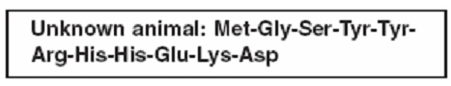

* 1. Horse: Met-Gly-Ser-Ser-Tre-Arg-Arg-Asp-His-Glu-Lys-Asp
  2. Dog: Met-Gly-Ser-Tyr-Tyr-Arg-His-Asp-Glu-Lys-Asp
  3. Cat: Met-Gly-Ser-Tyr-Tyr-Arg-His-His-Arg-Cys-Thre-Asp
  4. Mouse: Met-Gly-Ser-Tyr-Tyr-Arg-His-Glu-Val-Val-Leu

1. Over many generations, unrelated or distantly related species may come to resemble each other due to
   1. similar environmental factors
   2. similar genetic mutations
   3. homologous structural adaptations
   4. competition with each other
2. Bats are mammals and alligators are reptiles. Both, however, are vertebrates, and share a common evolutionary history with other vertebrates, including a bony skeleton. The bony wing of a bat and the bony foreleg of an alligator would be—
   1. analogous structures                     C. homologous structures
   2. vestigial features                           D. artificially selected features
3. Birds and insects both have wings use for flight, but we do not consider this similarity as evidence of relatedness because—
   1. bird wings function on different physics principles of lift.
   2. insect wings are vestigial.
   3. the wings are not homologous structures with a common ancestral origin.
   4. birds and insects did not evolve in the same region or live at the same time period.