- Refer to Model 1.
  - On what type of land does primary succession first begin to occur?

  - Does there appear to be any life on the land when primary succession begins?

  - Why would most plants such as shrubs and trees find it difficult to grow here?

- Refer to diagram B in Model 1.
  - What are the first organisms (colonizers) on this land?
  - Suggest the mechanisms by which the fist colonizers arrived on the land.
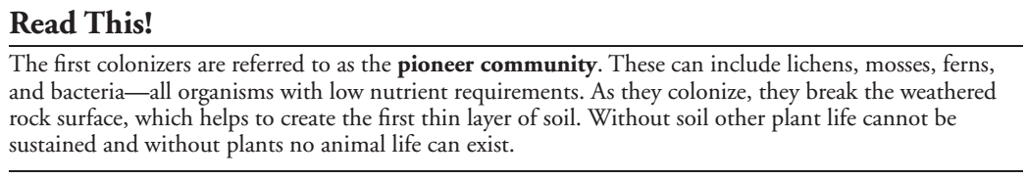
- Refer to Model 1.
  - Which diagram illustrates a pioneer community?

  - What are some of the features of the pioneer community?

- Notice the colonizers in diagrams C and D are taller and require more nutrients than those in the pioneer community. Considering what you already know about plants and photosynthesis, why might it be a competitive advantage for a plant to be taller?

- What happens to the pioneer organisms once the new colonizers become established?

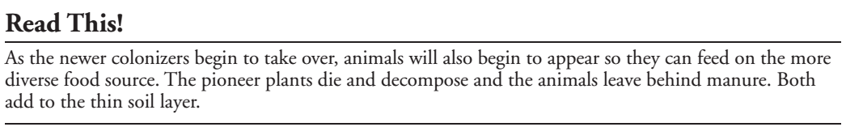
- What effect will the addition of animal waste and decayed plant matter have on the soil and land?

- How will grazing animals help plants to become established?

- How will the grazing animals prevent or control further colonization by other plants?

- Using the diagrams in Model 1 as a guide, develop a definition for the term primary succession, as it relates to the colonizing of barren land.

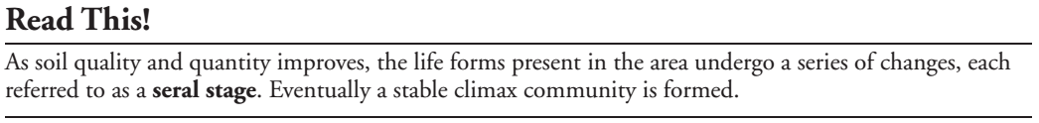
- Label the pictures in Model 1 as pioneer community, seral stages, and climax community.

- Most climax communities are mature forests. What features of mature forest species, such as oak trees, make them able to dominate and compete in the ecosystem?

- What environmental factors may affect the type of climax community that develops in an ecosystem?

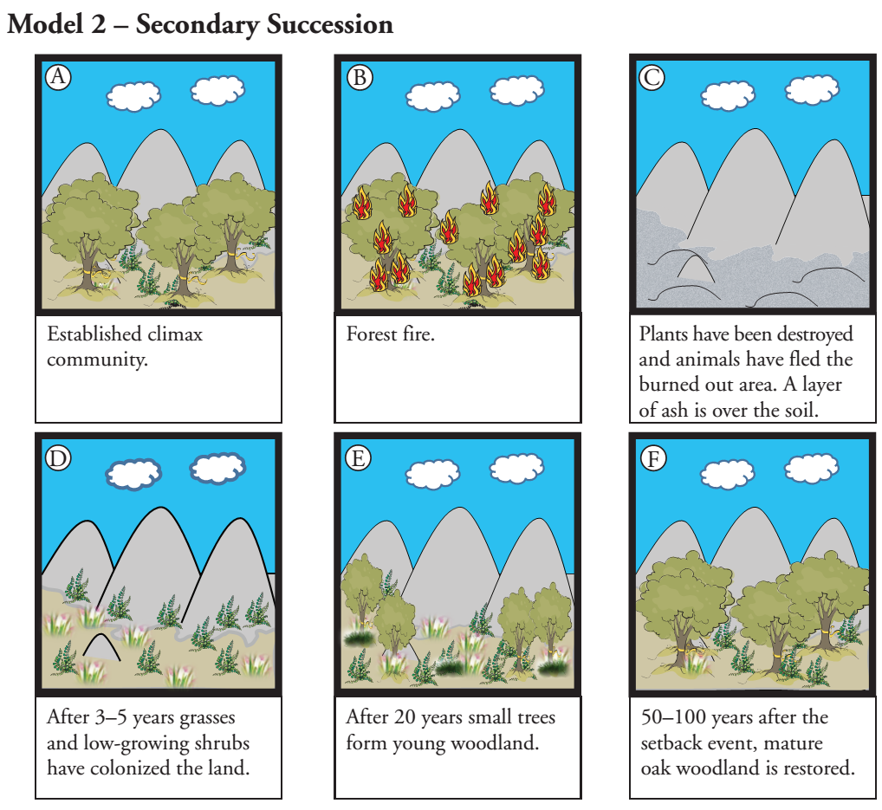
- Refer to the diagrams in Model 2.
  - What stage of development does diagram A represent?

  - What appears to have happened in diagram B?

  - What could be two causes of this event?

  - What process will begin again after this event has occurred?

- Can the ecosystem totally recover from this set-back? What evidence is given in Model 2?

- Why is the title of Model 2 Secondary Succession rather than Primary Succession?

- Consider each event below and determine if the recovery process for the environment will happen by primary succession or secondary succession.
  - Melting, receding glaciers.

  - Logging a wooded area.

  - Major flooding of a creek bed.

  - Volcanic eruption with lava flow.

