Chemistry JLab Assignment: Due __________________
This is an independent study assignment that will be graded for completion. In addition, depending on the grade you obtain on JLab, you may receive up to 10 points extra credit.
You must complete two 40 question practice SOL tests on Jlab. Please keep in mind that you may do this as many times as you want and only have to submit the top two test scores. Follow the instructions below to complete the assignment.

**Even if you don’t want the extra credit for your grade, you MUST COMPLETE 2 TESTS as part of a HW completion grade!
~~~~~~~~~~~~~~~~~~~~~~~~~~~~~~~~~~~~~~~~~~~~~~~~~~~~~~~~~~~~~~~~~~~~~~~
Instructions for JLab:
- Go to http://education.jlab.org/solquiz/index.html
- Choose “40” for the number of questions and click on the box for CHEMISTRY. Then click on “I’m Ready! Let’s Start!” and begin the practice test.

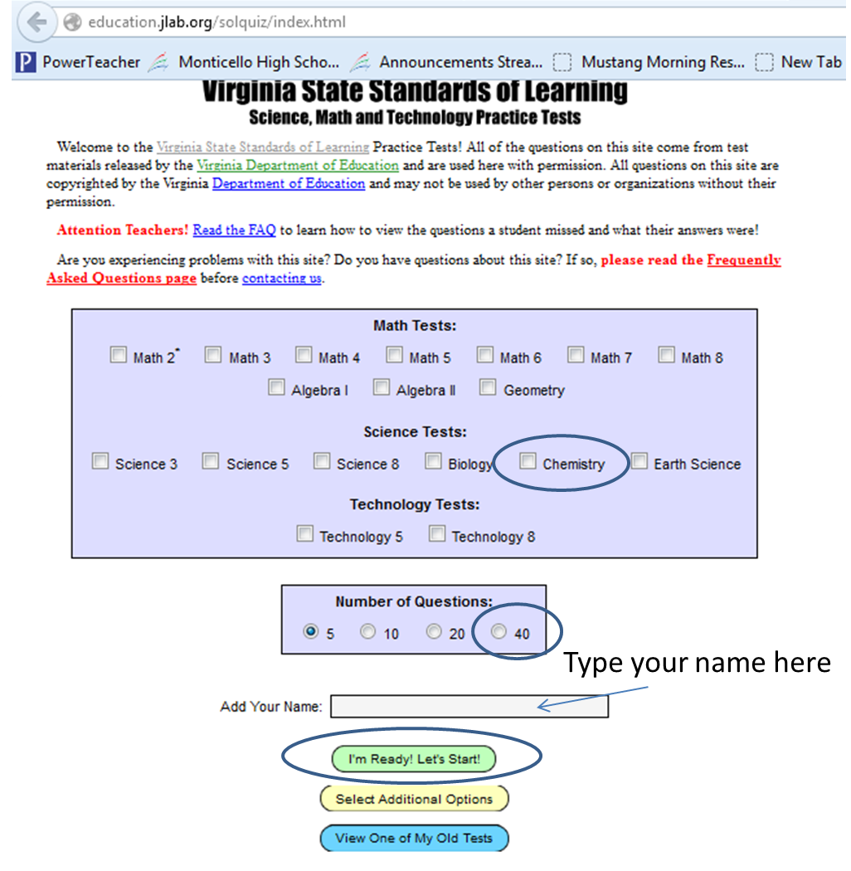

- If you want to receive extra credit, please retake the test until you have achieved 90 to 100% correct. When completed, please print your proof of completion and email to me.

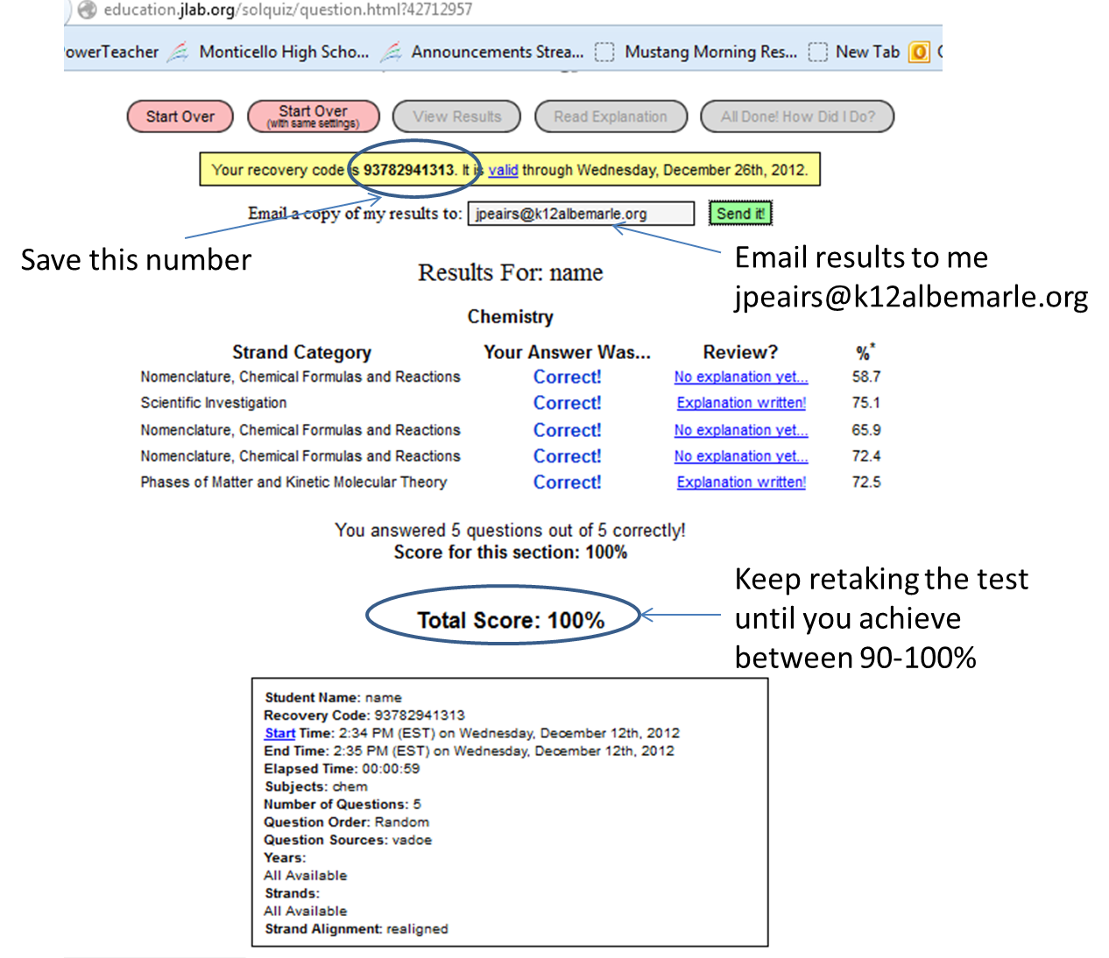

Email results to me at kye@k12albemarle.org

