**Atoms, Bonds Review WS Name __________________________**

1. Protons, neutrons, and electrons make up the atom
   1. Protons have a _________________ charge
   2. Neutrons have a ________________ charge
   3. Electrons have a ________________ charge
   4. ___________________ and _________________ are found in the nucleus of the atom.
   5. _____________________ are found orbiting the nucleus in shells.
2. 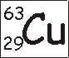What is the atomic mass and atomic number of Copper (Cu)?
   1. Atomic Mass = ___________
   2. Atomic Number = _________
   3. Determine the number of each particle type in an atom of copper:  
        
      Protons= _______  
      Neutrons = _________  
      Electrons = __________
3. 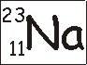Determine the number of each particle type in an atom of sodium (Na):  
   Protons= _______  
   Neutrons = _________  
   Electrons = __________
4. Complete the Bohr Diagram for an atom of Sodium

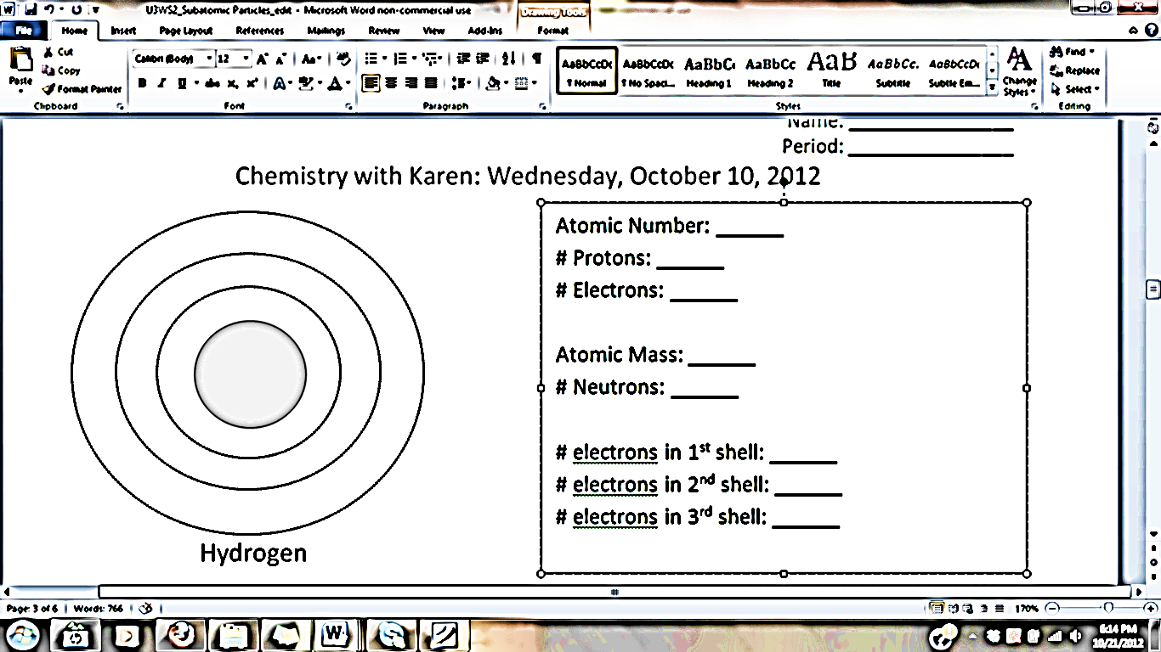

1. What are valence electrons?
2. Atoms bond in order to get a full valence shell. In general, how many valence electrons do atoms want to have? What is the exception?
3. There are two types of bonds: **ionic** and **covalent**.  
    ________________ bonding involves the transfer of electrons whereas  
    ________________ bonding involves the sharing of electrons.
4. What is the HONC Rule?