**UNIT 4 FRQ PRACTICE**

1. A sample of C2H4­(*g*) is placed in a previously evacuated, rigid 2.0 L container at 450 K.

C2H4(*g*) reacts readily with HCl(*g*) to produce C2H5Cl(*g*), as represented by the following

equation.

C2H4(*g*) + HCl(*g*) C2H5Cl(*g*) ΔHo = –72.6 kJ/mol

It is proposed that the formation of C­2H5Cl(*g*) proceeds via the following two-step mechanism.

Step 1: C2H4 + HCl C2H5+ + Cl– (slow step)

Step 2: C2H5+ + Cl– C2H5Cl (fast step)

(a) Write the rate law for the reaction that is consistent with the reaction mechanism above.

(b) Identify a species that behaves as an intermediate in the reaction mechanism above.

(c) Using the axes provided at right, draw a curve that shows the energy changes that occur during the

progress of the reaction.

Your curve should illustrate both the proposed two-step mechanism and the

enthalpy change for the reaction.

On the diagram, clearly indicate the

activation energy (Ea) for the rate-determining step in the reaction.

(d) Which of the following would produce a linear plot? Justify your answer.

[C2H4] vs. time ln[C2H4] vs. time 1/[C2H4] vs. time

1. Nitrogen monoxide gas can react with oxygen to produce nitrogen dioxide gas, as represented below.

2 NO (g) + O2 (g) 🡪 2 NO2 (g)

A rate study of the reaction yielded the data recorded in the table below.

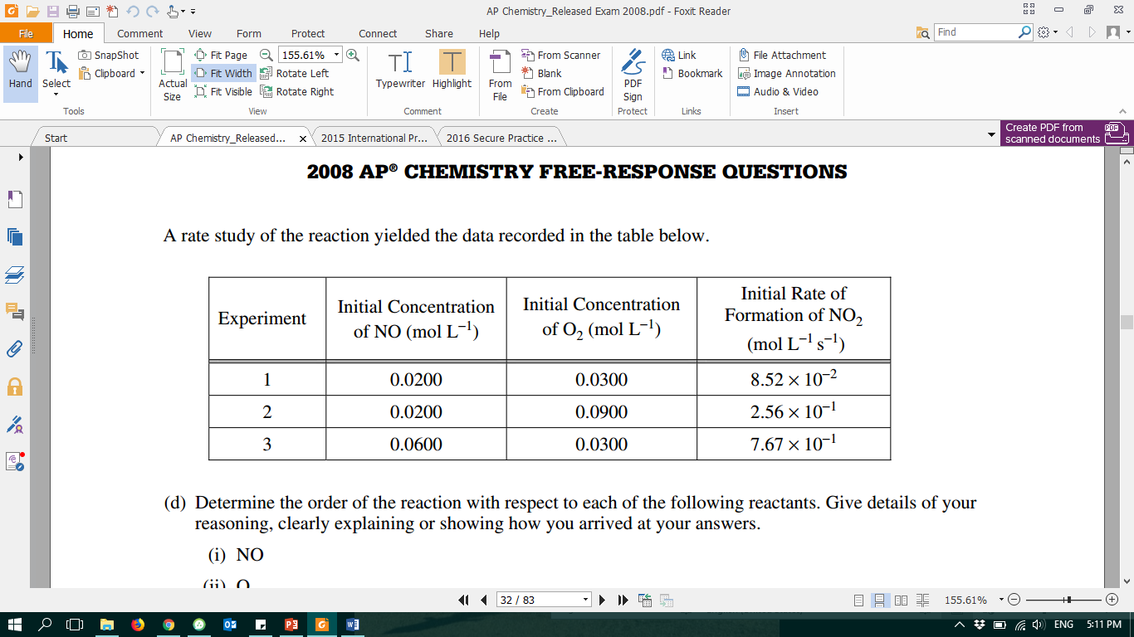

1. Determine the order of the reaction with respect to each of the following reactants. Give details of your reasoning, clearly explaining or showing how you arrived at your answers.
2. NO
3. O2
4. Write the expression for the rate law for the reaction as determined from the experimental data.
5. Determine the value of the rate constant for the reaction, clearly indicating units.