AP Chem: Unit 1 FRQ Practice
- Using principles of atomic and molecular structure and the information in the table below, answer the following questions about atomic fluorine, oxygen, and xenon, as well as some of their compounds.

- Write the equation for the ionization of atomic fluorine that requires 1,681.0 kJ·mol⁻¹.

- Account for the fact that the first ionization energy of atomic fluorine is greater than that of atomic oxygen. (You must discuss both atoms in your response.)

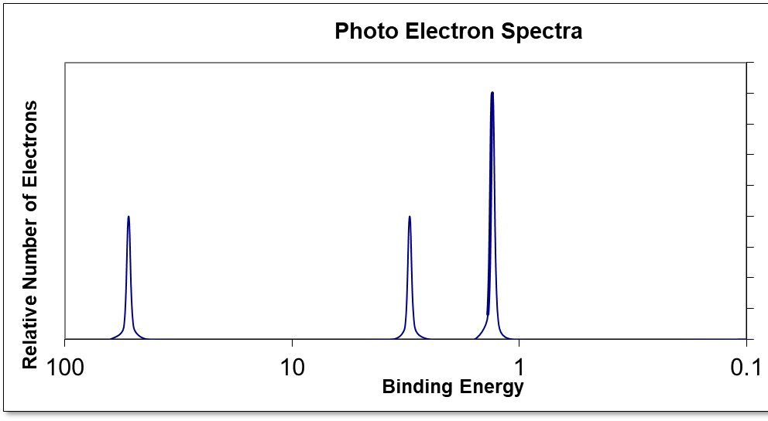
- Given the photoelectron spectra for oxygen, draw the photoelectron spectra for a neutral fluorine atom on the same graph.

- Predict whether the first ionization energy of atomic xenon is greater than, less than, or equal to the first ionization energy of atomic fluorine. Justify your prediction.

- Xenon can react with oxygen and fluorine to form compounds such as XeO₃ and XeF₄ .
  - Determine which Lewis structure is a better representation for the bonding in Xenon trioxide. Justify your choice based on formal charges.

  - In the box provided, draw the complete Lewis electron-dot diagram for XeF₄.
- On the basis of the Lewis electron-dot diagrams you identified and drew for part (e), predict the following:
  - The geometric shape of the XeO₃ molecule

  - The hybridization of the valence orbitals of xenon in XeF₄

- Predict whether the XeO₃ molecule is polar or nonpolar. Justify your prediction.

